Functional Requirement

Provide system design for an online-word2number translator. The online-workd2Numer translator should support:

1. Taken input as a string of words representing a number. e.g "Four Thousand Three Hundred fifty one" and return an integer representing the number. For the example, it should be 4351.
2. Bonus: Support history of translations done per user

1. Bonus: Translation history for one user should not be visible to other uses.

Capacity:

In memory dictionary

Approximately = 7000 char \* 2 bytes= 14000 14MB data to be in memory of server.

Application Flow Without Login

Database design without login

Application Flow With Login

Database design for Users with login

Global Users without login

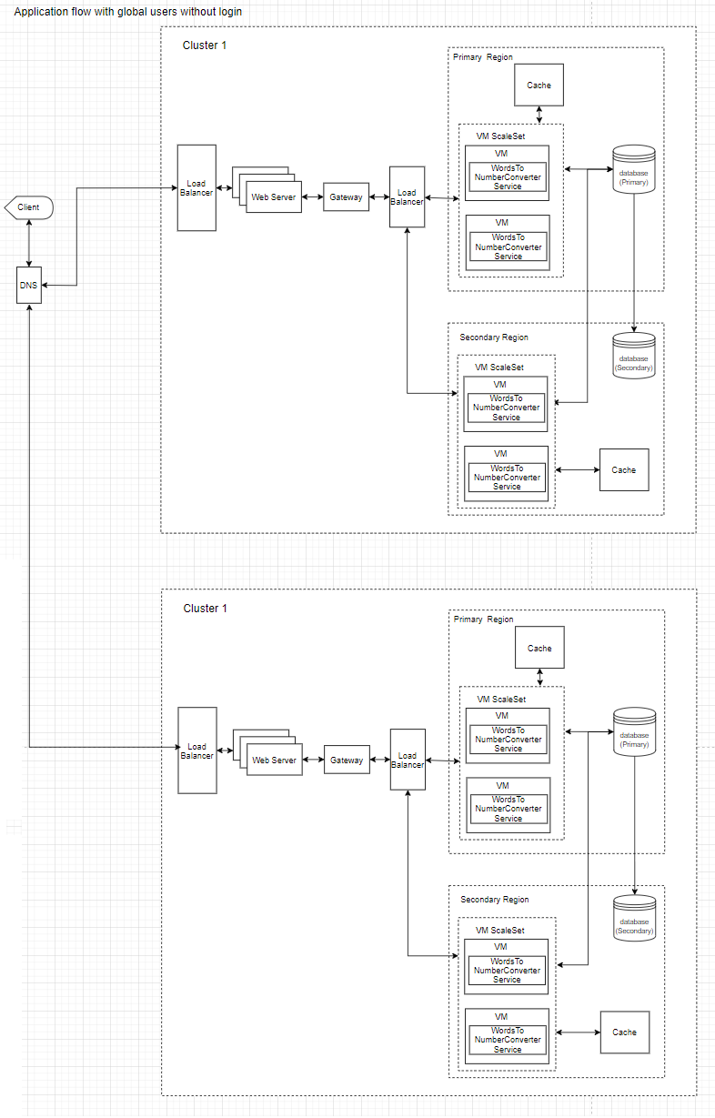

Global Users with login

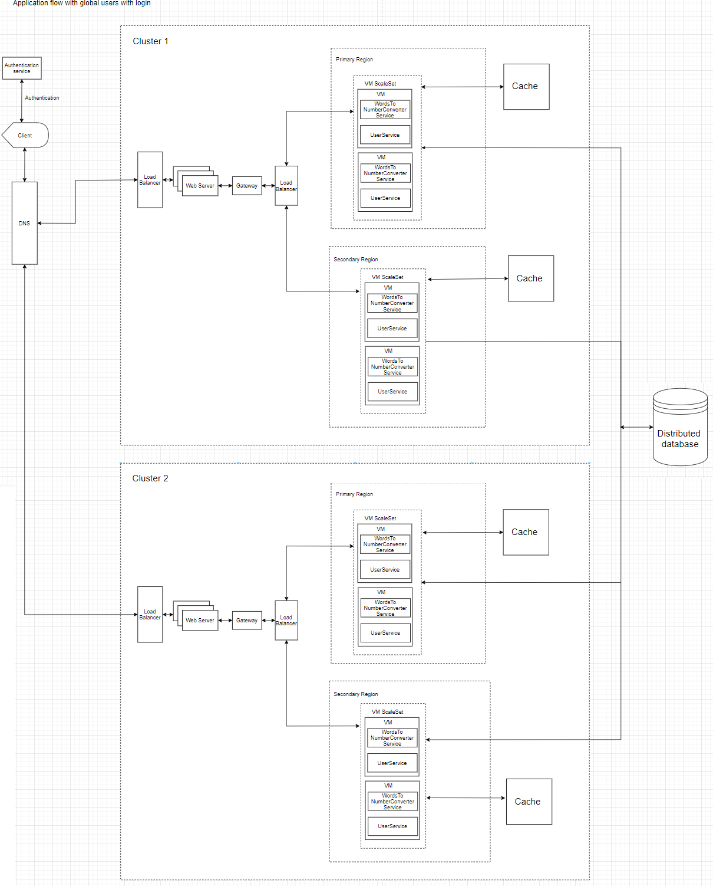

ApI’s for Users without login

api/convertwordtonumber

ConvertWordToNumber(string numberInWord)

--------------------------------------------------------------------

ApI’s for Users with login

api/convertwordtonumberforuser

ConvertWordToNumberForUser(string numberInWord, string userId)

api/getuserdetails

GetUserDetails(string email)

api/createuser

CreateUser(User user)

api/gettranslationhistoryofuser

GetTranslationHistoryofUser(string userId)